

MAT 202E - NUMERICAL

METHOD

CRN: 20964

INSTRUCTOR: BERK CANBERK

HOMEWORK-2

DUE DATE: 17.05.2013

TUĞRUL YATAĞAN

040100117

**Question 1**

Output of example usage

**>> X=[2 4 1.2 4.8 7.2 9 11];**

**>> Y=[-4 2.6 1.5 8.4 -1.1 2 3];**

**>> xx=1:0.001:11;**

**>> yy=quadratic_spline(X, Y, xx);**

**>> plot(xx, yy, X, Y, 'ro');**

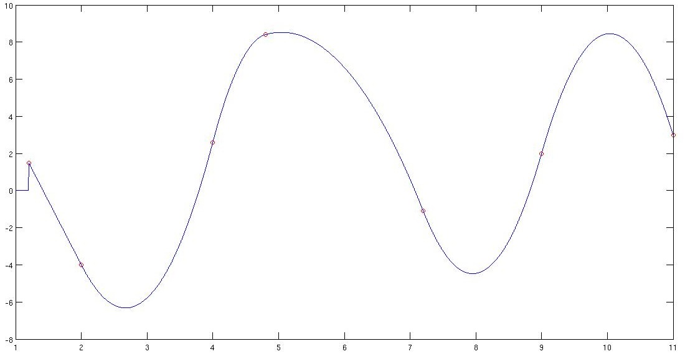

**Question 2**

**X2 ≤ -(X1)2 + 2X1 + 15 X2 ≥ (X1)2 - 4X1**

Multiply equations by 3

**3X2 ≤ -3(X1)2 + 6X1 + 45 3X2 ≥ 3(X1)2 - 12X1**

Add 2X1 to equations

**2X1 +3X2 ≤ -3(X1)2 + 8X1 + 45 3X2 + 2X1 ≥ 3(X1)2 - 10X1**

Combine these two equations

**3(X1)2 - 10X1 ≤ 2X1 +3X2 ≤ -3(X1)2 + 8X1 + 45**

Derivate right and left side equations and sync to zero for find min-max value of equations

**6X1 - 10 = 0 -6X1 + 8 = 0**

**X1 = 5/3 X1 = 4/3**

Min value for left side is: Max value for right side is:

**3(5/3)2 - 10(5/3) = -25/3 = -8,33 -3(4/3)2 + 8(4/3)+ 45 = 151/3=50,33**

Result:

**-8,33 ≤ 2X1 +3X2 ≤ 50,33**

**Question 3**

a, b and c are edge of triangle.

**a + b + c = 100**

Sum of two edges must be larger than the other edge to make a triangle. An edge of triangle can be large as half of sum of all edges but not equal.

**a + b > 50, c < 50 a + c > 50, b < 50 b + c > 50, a < 50**

**These graph for probability of a + b > 50 or a + c > 50 or b + c > 50**

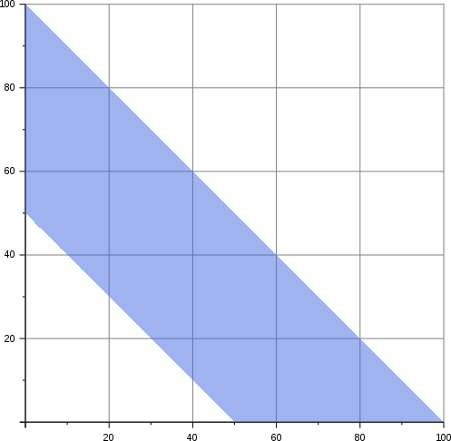

One edge must be smaller than 50 : **(100x100)/2 - (50x50)/2**

All probabilities : **(100x100)/2**

Probability is **(5000-1250)/5000 = (4-1)/4 = 3/4**